

FACULTY OF ENGINEERING AND INFORMATICS

DEPARTMENT OF APPLIED COMPUTER SCIENCE AND ARTIFICIAL INTELLIGENCE

ADVANVED MACHINE LEARNING- COURSEWORK

UFC Data Analysis (1993-2023) and Advancing MMA Judging System:

An AI-Based Approach for Transparency and Fairness

OLAMIDE OLADIMEJI 23027790

# ABSTRACT

This project delves into UFC data analysis and the development of an AI-based judging system for the Ultimate Fighting Championship (UFC), leveraging machine learning techniques and UFC fight statistics to provide real-time scoring aligned with UFC judging criteria. The project addresses the challenges of subjectivity and potential bias in the current judging process, aiming to enhance transparency, fairness, and spectator experience. By analyzing extensive datasets spanning from 1993 to 2023 and training a model based on the 10-point judging system currently utilized, the AI system offers insights into judging decision fight outcomes and contributes to combat sports research. Ethical considerations surrounding AI in sports judging are also addressed to ensure fairness and integrity. The AI MMA Judge system presents a promising innovation with the potential to revolutionize mixed martial arts competitions.

# TABLE OF CONTENTS

ABSTRACT 1

TABLE OF CONTENTS 2

INTRODUCTION 3

PROBLEM DESCRIPTION 4

PROJECT MOTIVATION 5

OBJECTIVE 6

RESEARCH CHALLENGES 7

1. Data Complexity and Variability 7

2. Subjectivity in Judging Criteria 8

3. Model Interpretability and Explainability 8

4. Data Collection Methods 8

5. Ethical and Regulatory Considerations 8

LITERATURE REVIEW 9

DATA DESCRIPTION 9

DATA COLLECTION AND PREPARATION 11

DATA ANALYSIS 11

MODEL DEVELOPMENT 13

Data Preparation: 13

Oversampling using SMOTE 14

Model Evaluation: 14

MODEL PREDICTION AND PERFORMANCE 15

Critical Analysis 17

SYSTEM DESIGN 18

Integration with Existing Systems 18

User Interface 18

Insights 18

Limitations and Ethical Considerations 19

CONCLUSION 20

Potential Impacts 20

Future Work 20

REFERENCES 21

APPENDIX 22

\

\

# INTRODUCTION

Since its establishment in 1993, the Ultimate Fighting Championship (UFC) has emerged as a dominant force in the realm of mixed martial arts (MMA), captivating audiences worldwide, including notable figures such as Mark Zuckerberg, Donald Trump, and other enthusiasts. Widely regarded as one of the fastest-growing sports in history (mmachannel, 2020), the UFC was conceived by the Gracie family, spearheaded by Rorion, with the intention of providing a platform to experiment with various fighting techniques and determine the superiority of different martial arts disciplines. MMA, by its very nature, amalgamates a diverse array of combat sports, including wrestling, Brazilian Jiu-Jitsu, Sambo, kickboxing, Muay Thai, and boxing, fostering a dynamic and eclectic competitive environment.

The extensive dataset spanning from 1993 to 2023 encapsulates a wealth of information regarding UFC events, offering a compelling opportunity for comprehensive analysis and insightful modeling. This project pivots towards addressing the inherent challenges within the UFC's judging system, particularly in fights that extend to a decision. Controversies surrounding subjective judgments and potential biases underscore the necessity for a more transparent and objective adjudication process.

The emphasis now shifts towards the development of an AI-based judging system, leveraging UFC fight statistics and adherence to established judging rules and criteria.

# PROBLEM DESCRIPTION

While the UFC has solidified its position as a global powerhouse in MMA, the integrity of its judging system has come under scrutiny (Pandey, 2023). In fights that reach a decision, the subjective nature of human judgment and the potential for bias have led to controversies and debates within the MMA community. These challenges highlight the need for a more transparent and objective adjudication process that aligns with the essence of fair competition. Traditional judging systems rely on human judges to assess fights based on their observations and interpretations of the action. However, this approach is susceptible to individual biases, inconsistencies, and human error, which can compromise the accuracy and fairness of the outcomes. Moreover, the complexity of MMA fights, characterized by diverse fighting styles and strategies, further complicates the task of judging and evaluating performance. To address these challenges, there is a growing interest in leveraging artificial intelligence (AI) and machine learning techniques to develop a more reliable and impartial judging system for UFC events. By harnessing the vast trove of fight statistics and adhering to established judging rules and criteria, an AI-based approach offers the potential to enhance the objectivity and credibility of fight outcome decisions.

# PROJECT MOTIVATION

The motivation behind this project stems from a desire to address the inherent challenges within the Ultimate Fighting Championship (UFC) judging system, particularly in fights that extend to a decision. As a passionate follower of the UFC, I've witnessed firsthand the controversies and debates surrounding subjective judgments and potential biases in fight outcomes. Driven by a commitment to enhancing the transparency, consistency, and fairness of fight adjudication, I am motivated to explore the potential of artificial intelligence (AI) and machine learning techniques in revolutionizing the judging process. By leveraging UFC fight statistics and adhering to established judging rules and criteria, I aim to develop an AI-based judging system that can provide real-time scoring aligned with UFC standards. Through this endeavor, I aspire to contribute to the evolution of combat sports by introducing a more objective and impartial adjudication process. By leveraging technology to overcome the limitations of traditional judging methods, I aim to improve the overall spectator experience and integrity of the sport.

Ultimately, my motivation lies in leveraging my passion for the UFC and my expertise in data analysis and machine learning to introduce innovative solutions that enhance the sport's competitive integrity and ensure fair outcomes for all athletes involved.

# OBJECTIVE

Develop an AI Judging System:

The primary objective is to design and implement an AI-based judging system tailored for the Ultimate Fighting Championship (UFC) that can objectively evaluate fights that go the distance (3 or 5 rounds). This system will leverage machine learning techniques and UFC fight statistics to provide real-time scoring aligned with UFC judging criteria.

Enhance Transparency and Fairness:

The system aims to address the challenges of subjectivity and potential bias in the current judging process by providing transparent and consistent assessments of fight outcomes. By integrating statistical analysis and machine learning, the objective is to promote fairness and integrity in fight adjudication.

Improve Spectator Experience:

Another objective is to improve the overall spectator experience by offering a more accurate and objective assessment of fight outcomes. By providing real-time scoring based on quantifiable fight data, the AI judging system aims to enhance viewer engagement and satisfaction.

Contribute to Combat Sports Research:

This project also seeks to contribute to the body of research on combat sports dynamics by exploring the application of data analytics and machine learning in the context of MMA judging. By investigating patterns and trends in UFC fights, the objective is to gain insights into the strategic components and factors influencing fight outcomes.

Promote Ethical Considerations:

As part of the objectives, ethical considerations surrounding the use of AI in sports judging will be addressed. The project aims to ensure that the AI judging system upholds ethical standards and respects the principles of fairness, transparency, and integrity in sports competition.

# RESEARCH CHALLENGES

1. Data Complexity and Variability: One of the primary challenges is the inherent complexity and variability of UFC fight data. MMA fights involve a wide range of techniques, styles, and strategies, making it challenging to capture all relevant factors accurately. Devising effective methods to process and analyze diverse data streams, including fighter statistics, fight outcomes, and contextual information, presents a significant research challenge.
2. Subjectivity in Judging Criteria: UFC judging criteria, while well-defined, can still be subjective in interpretation. Identifying and quantifying the nuances of criteria such as effective striking, grappling, octagon control, and aggression poses a challenge. Developing machine learning models that can accurately capture and apply these criteria in a consistent and objective manner requires careful consideration and validation.

1. Model Interpretability and Explanation ability: As AI-based judging systems become more sophisticated, ensuring the interpretability and explanation ability of model decisions becomes crucial. Balancing the complexity of machine learning algorithms with the need for transparency and understanding presents a challenge. Researchers must explore techniques to enhance model interpretability without compromising performance.

1. Data Collection Methods: The quality and reliability of UFC fight data can vary due to factors such as data collection methods, reporting inconsistencies, and data errors. Ensuring the integrity and accuracy of the input data is essential for building robust machine learning models. So, I personally used two websites, ufcfightstats and ufc.com/scorecards to get data for each round, one after the other,363 total and then accumulated them for the model training.

1. Ethical and Regulatory Considerations: The integration of AI in sports judging raises ethical and regulatory concerns regarding fairness, accountability, and privacy. Ensuring that AI judging systems adhere to ethical guidelines and regulatory standards while maintaining fairness and transparency is a complex challenge. Researchers must navigate these considerations to gain acceptance and trust in the implementation of AI-based judging systems.

1. Acceptance and Adoption by Stakeholders: The acceptance and adoption of AI-based judging systems by key stakeholders, including fighters, coaches, officials, and fans, present challenges. Overcoming skepticism, building trust, and demonstrating the value proposition of AI in improving judging accuracy and fairness require effective communication and engagement strategies. Researchers must work collaboratively with stakeholders to address concerns and promote acceptance of AI technology in combat sports judging.

# 

# LITERATURE REVIEW

## Description and Justification of Algorithm, Tool, and Process Choice

1. Algorithm: Random Forest Classifier

Description: The Random Forest Classifier is an ensemble learning method for classification that operates by constructing a multitude of decision trees at training time and outputting the class that is the mode of the classes of the individual trees.

Justification: This algorithm was chosen for its effectiveness in handling high-dimensional datasets and its ability to provide robust generalization. It performs well on complex datasets without extensive hyperparameter tuning and can handle both numerical and categorical data effectively, which is ideal for the varied nature of fight statistics and judge scores.

2. Tool: Scikit-Learn and Imbalanced-Learn (SMOTE)

Description: Scikit-Learn provides simple and efficient tools for data mining and data analysis, including a plethora of built-in machine learning algorithms and preprocessing methods. SMOTE (Synthetic Minority Over-sampling Technique) from Imbalanced-Learn helps to overcome the problem of imbalanced data by increasing the number of instances in the dataset with under-represented classes.

Justification: Scikit-Learn is a widely used library that supports rapid development and evaluation of ML models with its comprehensive API. The SMOTE technique is essential for balancing the dataset, which is crucial for training a fair and unbiased model, especially given the varied and potentially imbalanced nature of judge scores in UFC data.

3. Process: Data Encoding and Resampling

Description: Before training, categorical scores from judges are transformed into numerical values using Label Encoding. The features are differences in fight statistics, which are calculated directly from the dataset. For handling class imbalance, SMOTE is applied to the training data to ensure that the minority classes are adequately represented.

Justification: Label Encoding simplifies the representation of categorical data, making it suitable for input into machine learning algorithms. Calculating differences in fight statistics as features allows the model to directly assess the impact of each fighter’s performance relative to their opponent, which is more indicative of the outcome than raw statistics. SMOTE ensures that the model is trained on a balanced view of the outcomes, improving its accuracy and fairness.

4. Evaluation: Accuracy Score and Confusion Matrix

Description: The model’s performance is evaluated using accuracy scores and detailed by a confusion matrix. These metrics help understand the model's overall effectiveness and its performance across different classes.

Justification: Accuracy provides a quick snapshot of the overall effectiveness of the model, which is useful for comparing different models or configurations. The confusion matrix is crucial for identifying classes where the model may be underperforming, indicating potential areas of bias or weaknesses in how the model interprets the data.

## DATA DESCRIPTION

Here is an explanation of each column in the dataset:

Initial Dataset (for explicit data analysis):

|  |  |
| --- | --- |
| Location | The location where the MMA (Mixed Martial Arts) event took place (e.g., Austin, Texas, USA) |
| Fighter 1 | The name of the first fighter in the match |
| Fighter 2 | The name of the second fighter in the match |
| Fighter_1_KD | Number of knockdowns scored by Fighter 1 in the match |
| Fighter_2_KD | Number of knockdowns scored by Fighter 2 in the match |
| Fighter_1_STR | Significant strikes landed by Fighter 1 |
| Fighter_2_STR | Significant strikes landed by Fighter 2 |
| Fighter_1_TD | Number of takedowns executed by Fighter 1 |
| Fighter_1_SUB | Number of takedowns executed by Fighter 1 |
| Fighter_2_SUB | Number of takedowns executed by Fighter 2 |
| Weight Class | The weight class of the MMA fight (e.g., Lightweight, Middleweight) |
| Method | The method by which the fight was decided (e.g., KO/TKO, SUB for knockout or submission) |
| Round | The round in which the fight ended |
| Time | The time at which the fight ended |
| Event | The name of the MMA event |
| Winner | The name of the fighter who won |

Final Dataset (for training judging model includes):

|  |  |
| --- | --- |
| Fighter_A_SS | Fighter A significant strikes |
| Fighter_A_KD | Fighter A Knockdowns |
| Fighter_A_takedown | Fighter A Takedowns |
| Fighter_A_control_time | Fighter A Control time |
| Fighter_A_damage | Fighter A damage induced (Bleeding) |
| Fighter_A_violation | Fighter A (any point deducted due to a foul) |
| Fighter_A_fight_ending | Fighter A fight ending situations induced |
| Score_Fighter_A1 | Fighter A’s Score by Judge 1 |
| Score_Fighter_A2 | Fighter A’s Score by Judge 2 |
| Score_Fighter_A3 | Fighter A’s Score by Judge 3 |
| Fighter_ B _SS | Fighter B significant strikes |
| Fighter_ B _KD | Fighter B Knockdowns |
| Fighter_ B _takedown | Fighter B Takedowns |
| Fighter**_** B **_**control_time | Fighter B Control time |
| Fighter_ B _damage | Fighter B damage induced (Bleeding) |
| Fighter_ B _violation | Fighter B violation (any point deducted due to a foul) |
| Fighter_B_fight_ending | Fighter B fight ending situations induced |
| Score_Fighter_ B1 | Fighter B’s Score by Judge 1 |
| Score_Fighter_B2 | Fighter B’s Score by Judge 2 |
| Score_Fighter_B3 | Fighter B’s Score by Judge 3 |
| Round | Fight Round |
| Fighter A name | Fighter A Name |
| Fighter B name | Fighter B Name |

## DATA COLLECTION AND PREPARATION

For data analysis, we start with the initial dataset sourced from Kaggle (www.kaggle.com, 2024), which contains columns such as **Location**, **Fighter 1**, **Fighter 2**, **Fighter_1_KD** etc., as shown in the table above. These columns provide comprehensive information about each MMA event, including the location, fighters, fight statistics, weight class, fight outcome method, round, time, event name, and winner.

To prepare the data for modeling, we needed to extract fights that went to decisions, as judging the rounds is the focus of our model. Thus, we filtered the dataset to include only fights that ended in decisions, such as unanimous decisions (U-DEC), split decisions (S-DEC), and majority decisions (M-DEC). This formed the basis of our second dataset, which is used for training the judging model.

Once we had the filtered dataset, we sourced statistics from (ufcstats.com, n.d.) for individual rounds stats, and (www.ufc.com, 2021) for the judges' scorecards for each round, formulated the features required for the judging model. This involved creating new columns for each fighter, such as **Fighter_A_SS**, **Fighter_A_KD**, **Fighter_A_takedown**, **Fighter_A_control_time**, **Fighter_A_damage**, **Fighter_A_violation**, **Fighter_A_fight_ending**, and similar columns for Fighter B. Additionally, we included columns for judge scores for each fighter and other relevant information such as round number and fighter names.

By structuring the data in this way, we were able to create a dataset suitable for training the judging model, with each row representing a unique round of a fight and containing relevant statistics for both fighters, judge scores, and other contextual information.

## 

## DATA ANALYSIS

* From the data analysis, it can already be established that most fights go to the judges (decision, U-DEC) as in fig 1.

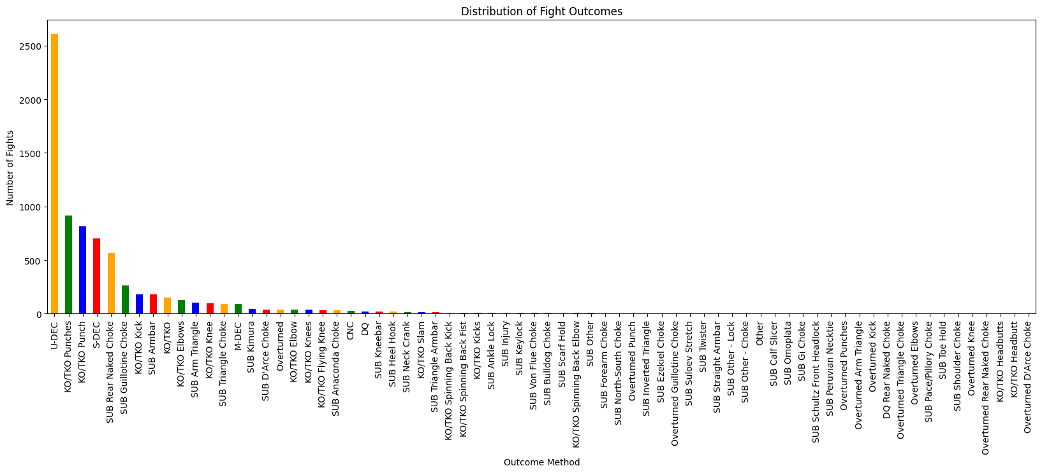Fig 1: Distribution of fight outcomes.

* Most fights are 3 rounds, as 5 rounds are only for main events or title fights.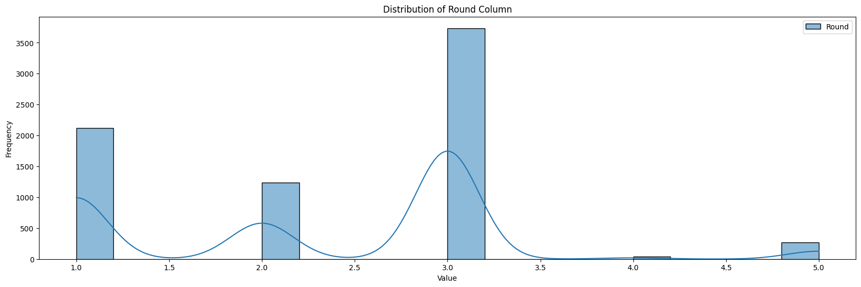Fig 2: Distribution of round column.

Fig 3: Scatter plot of Fighter 1 VS Fighter 2.

* Another important thing derived from data analysis as seen in fig 4 is that the most predominant way to win, when a fight does not go the distance, is by rear-naked choke, also 3rd and 4th position, guillotine choke and armbar respectively also leads to wrestling which then gives us a valuable information, wrestling is the strongest background in mma, aspiring fighters could employ this into their training and grooming stage, as data has proven it to be the most successful / efficient.

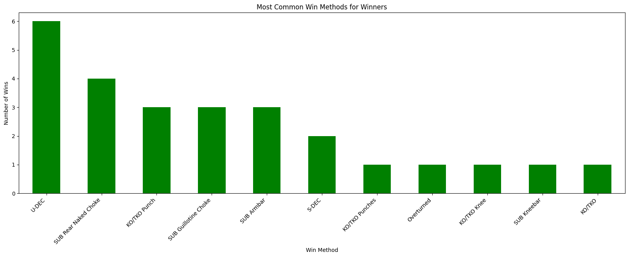Fig 3: Most common win for winners.

## 

## MODEL DEVELOPMENT

### Data Preparation:

* + The dataset is loaded from an Excel file named "UFC DATA UPDATED.xlsx".
  + Four new features are created: **Diff_SS**, **Diff_KD**, **Diff_TD**, and **Diff_CTRL**, representing the differences in fight statistics between Fighter A and Fighter B. These features capture the comparative performance of each fighter in terms of significant strikes, knockdowns, takedowns, and control time.
  + Scores from all judges (Score_Fighter_A1, Score_Fighter_A2, Score_Fighter_A3, Score_Fighter_B1, Score_Fighter_B2, Score_Fighter_B3) are encoded using **LabelEncoder()** to convert categorical scores into numerical labels.
  + The encoded scores are combined into a single target variable named **Combined_Scores**.
  + Features (**X**) and labels (**y**) are prepared for model training, with **X** containing the calculated differences in fight statistics and **y** representing the combined scores.
  + The dataset is split into training and testing sets using a test size of 20% and a random state of 42 to ensure reproducibility.

Oversampling using SMOTE**:**

* + Synthetic Minority Over-sampling Technique is employed to address class imbalance in the training data. It generates synthetic samples for the minority class to balance the distribution of classes.
  + The minimum class size is checked to ensure there are enough samples for SMOTE to be applied. The **k_neighbors** parameter is set to ensure that it is less than the smallest class size minus one.
  + If there are enough samples, SMOTE is applied to oversample the minority class; otherwise, the original data is used for training.
  + A Random Forest classifier is trained using GridSearchCV to find the optimal hyperparameters. The hyperparameters tuned include the number of estimators (**n_estimators**), maximum depth of each tree (**max_depth**), minimum number of samples required to split an internal node (**min_samples_split**), and minimum number of samples required to be a leaf node (**min_samples_leaf**).
  + The best parameters obtained from the grid search are used to train the final Random Forest model (**rf_best**).
  + Both the trained model and the encoder used for label encoding are saved to disk using pickle for future use.

### Model Evaluation:

* + The trained model is used to predict scores on the test set (**X_test**).
  + The accuracy of the model is calculated using **accuracy_score**.
  + A more detailed performance evaluation is provided using **classification_report**, which includes precision, recall, F1-score, and support for each class.
  + Additionally, a confusion matrix is plotted using **confusion_matrix** and **seaborn** to visualize the model's performance in predicting each class.

## MODEL PREDICTION AND PERFORMANCE

The constructed model underwent training to predict outcomes based on the provided UFC data. It was then evaluated using a test set to assess its prediction accuracy. The test accuracy achieved was approximately 80.82%, indicating that the model was able to correctly predict the outcome in a significant majority of the cases. 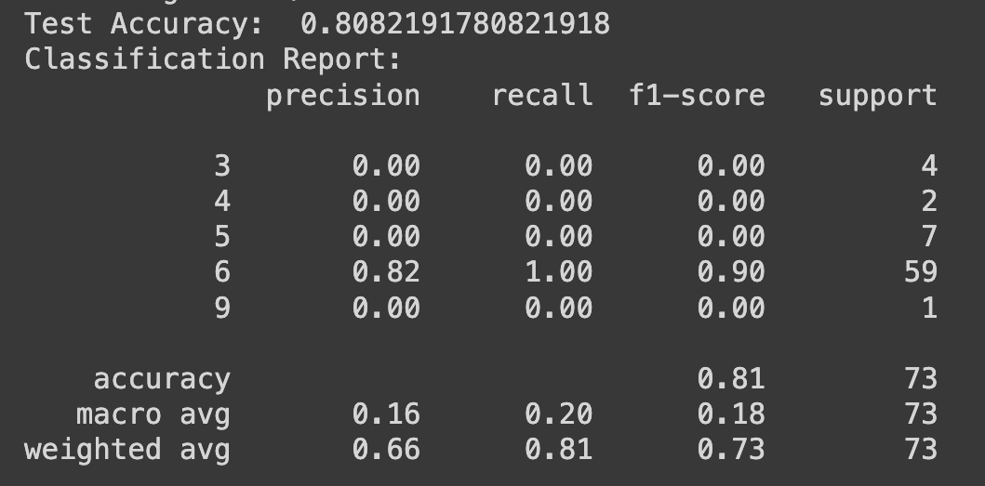

Fig 4: Classification Report.

Fi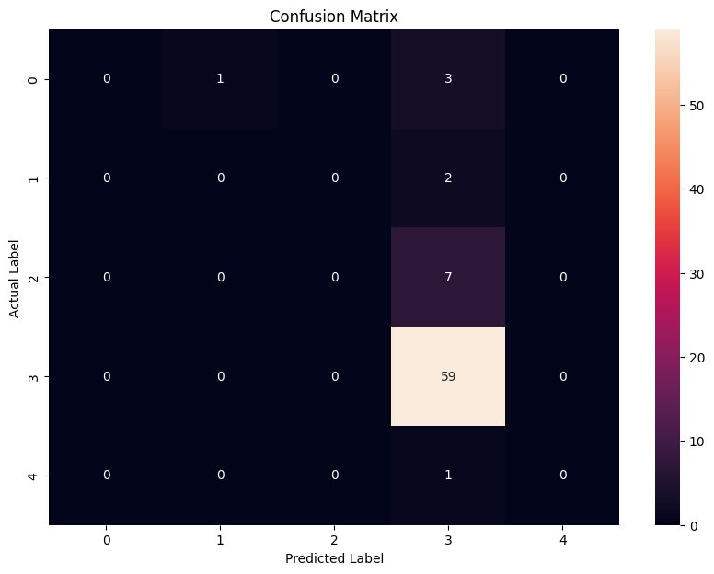Fig 5: Confusion Matrix.

A closer look at the confusion matrix reveals that the model is highly accurate in predicting class '6', with 59 true positive predictions. However, it seems to struggle with all other classes, with zero true positives for classes '3', '4', '5', and '9'. This suggests a bias towards the majority class, which is a result of the imbalanced dataset and the fact that SMOTE could not be applied due to insufficient samples in the minority classes.

## Critical Analysis

The classification report and the confusion matrix indicate a significant imbalance in the model's predictive performance across different classes. While the model excels at identifying class '6', it fails to correctly predict any instances of the minority classes ('3', '4', '5', '9'). This is symptomatic of a model that has overfit to the majority class, rendering it less sensitive to the nuances of the dataset's less represented classes.

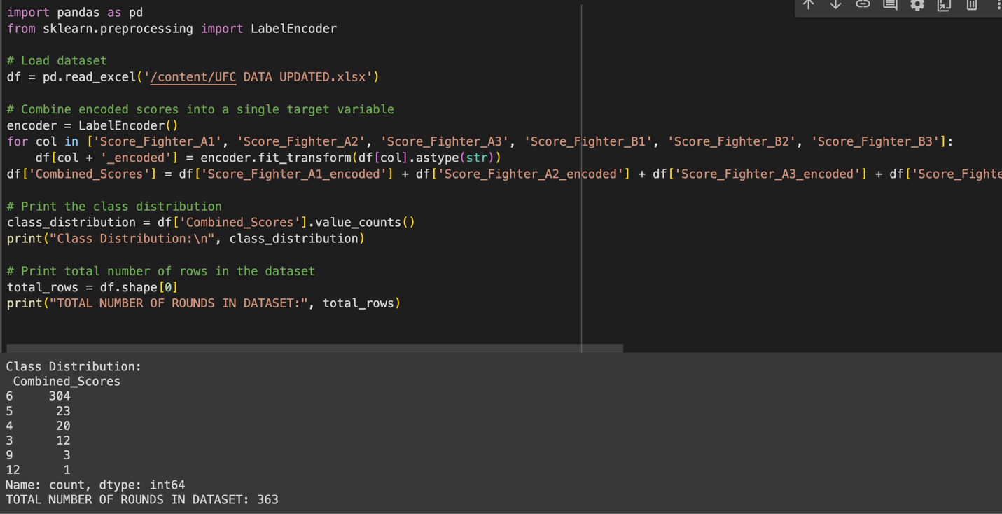

This imbalance in the dataset's class distribution has limited the model's ability to generalize well across all outcomes. Despite SMOTE being considered for addressing this imbalance, the technique was not applicable due to the extremely small size of the least represented class. Consequently, the model's utility is restricted, with a potential bias that favors the majority class.

For a more robust model, strategies to enrich the dataset with more samples from underrepresented classes should be pursued. Additionally, alternative techniques for handling imbalanced data could be explored, such as adjusting class weights within the model or employing more sophisticated oversampling methods.

A crucial takeaway is the importance of a well-distributed dataset in training machine learning models for classification tasks. The quality and variety of data can significantly influence the outcome, and as such, should be a primary consideration in future iterations of model development.

## SYSTEM DESIGN

Integration with Existing Systems**:** The AI system can seamlessly integrate into the current UFC judging framework by complementing the existing human judges. Since the model is designed to predict rounds based on the UFC/MMA 10-point scoring system, it can provide an additional perspective on each round's outcome.

For example, if there are three human judges scoring a round between two fighters, each judge might give a score of 10-9 for a total of 30-27. In this scenario, the AI model can replace one human judge, providing its prediction based on the round statistics.

This integration maintains the integrity of the current judging framework while enhancing it with AI-driven insights. It ensures that the final decision still relies on a combination of human judgment and AI analysis, thereby reducing the potential for bias and errors.

User Interface**:** The system's decisions could be presented through a user-friendly interface accessible to viewers in the arena.

During the fight, the AI interface could display real-time predictions for each round based on the round statistics. This interface would update continuously as the round progresses, providing instant feedback.

Once the round concludes, the AI's judgment for that round could be displayed prominently. At the end of the fight, the announcer can collect the scores from the two human judges, along with a printed version of the AI's judgments. These scores can then be summed up and announced in the same manner as usual, ensuring a fair and transparent scoring process.

DISCUSSION

Insights**:** One interesting finding from the model's decision patterns is the potential for identifying subtle differences in performance that may not be immediately apparent to human judges. The AI model can analyze detailed round statistics and identify patterns or trends that might influence the outcome of a round. For example, it may detect nuanced variations in striking accuracy, takedown defense, or control time that could sway the round in favor of one fighter over another.

Additionally, the AI model's consistent application of judging criteria across all rounds and fights can provide valuable insights into the effectiveness of different fighting styles and techniques. By analyzing a large dataset of fights, the model may uncover trends or correlations between specific performance metrics and fight outcomes, helping fighters and coaches refine their strategies.

Limitations and Ethical Considerations**:** Despite its potential benefits, the current model also has several limitations and ethical considerations that need to be addressed:

* **Data Bias:** The model's predictions are only as good as the data it is trained on. If the training data contains biases or inaccuracies, the model's judgments may reflect those biases, potentially perpetuating unfairness, or discrimination.
* **Complexity of MMA:** Mixed martial arts are a complex and dynamic sport with many variables that can influence the outcome of a fight. While the model considers various performance metrics, it may not capture all relevant factors, such as fighter strategy, conditioning, or mental resilience.
* **Human Judgment vs. AI:** There is a risk of overreliance on AI in sports judging, leading to a reduction in the role of human judgment and intuition. It is essential to strike a balance between the objective analysis provided by AI and the subjective expertise of human judges.
* **Transparency and Accountability:** The inner workings of AI models, including how they arrive at their decisions, must be transparent and accountable. Stakeholders, including fighters, coaches, and fans, should have visibility into the model's decision-making process to ensure fairness and trustworthiness.
* **Continual Improvement:** AI models in sports judging should be continually refined and updated to adapt to evolving trends and developments in the sport. Regular evaluation and validation against real-world outcomes are essential to maintain the model's accuracy and effectiveness over time.

# CONCLUSION

The AI MMA Judge system can revolutionize the landscape of mixed martial arts judging by providing objective and consistent assessments of fighter performance. By leveraging advanced machine learning algorithms, the system can analyze round-by-round statistics and apply the UFC's 10-point scoring system to determine the winner of each round. This technology aims to complement existing human judges by offering an additional perspective based on data-driven analysis.

Potential Impacts**:**

1. **Fairness and Consistency:** The AI MMA Judge system can contribute to greater fairness and consistency in fight outcomes by applying standardized criteria across all rounds and fights. This reduces the likelihood of subjective biases influencing the judging process.
2. **Enhanced Transparency:** With transparent decision-making processes and real-time scoring updates, the system promotes greater transparency in judging, allowing fighters, coaches, and fans to understand how each round is scored.
3. **Educational Tool:** The system serves as an educational tool for fighters and coaches, providing valuable insights into performance strengths and weaknesses. Analyzing the AI's judgments can help fighters refine their strategies and improve their overall performance.
4. **Regulatory Compliance:** By aligning with existing UFC judging criteria and regulations, the AI MMA Judge system can facilitate regulatory acceptance and adoption within the MMA community.

Future Work**:**

1. **Model Refinement:** Continual refinement of the AI model is essential to improve its accuracy and effectiveness. This involves incorporating additional performance metrics, refining feature selection, and optimizing model parameters through ongoing training and validation.
2. **Integration with Live Events:** Future development efforts should focus on integrating the AI MMA Judge system with live MMA events, allowing real-time scoring updates to be displayed alongside traditional judging methods.
3. **Regulatory Acceptance:** Collaborating with MMA governing bodies and regulatory agencies is crucial for gaining acceptance and endorsement of the AI MMA Judge system. This involves conducting validation studies, engaging stakeholders, and addressing any concerns related to fairness, transparency, and accuracy.
4. **User Interface Enhancement:** Enhancing the user interface of the AI MMA Judge system to make it more intuitive and user-friendly for judges, commentators, and viewers will improve its usability and adoption.
5. **Ethical Considerations:** Continued attention to ethical considerations, such as data bias, transparency, and accountability, is necessary to ensure that the AI MMA Judge system upholds the integrity of the sport and promotes fairness for all stakeholders.

Overall, the AI MMA Judge system represents a promising innovation in sports judging that has the potential to elevate the integrity, transparency, and fairness of mixed martial arts competitions. Through ongoing development and collaboration with stakeholders, it can contribute to a more informed and equitable judging process in the world of MMA.

# REFERENCES

Pandey, P. (2023). *Former UFC fighter reveals only scenario which would make Dana White fix the judging system*. [online] sportskeeda. Available at: <https://www.sportskeeda.com/mma/news-former-ufc-fighter-reveals-scenario-make-dana-white-fix-judging-system#:~:text=The%20UFC%27s%20judging%20system%20has%20come%20under%20intense,Albazi%2C%20which%20concluded%20in%20a%20highly%20controversial%20manner>. [Accessed 25 Apr. 2024].

ufcstats.com. (n.d.). *Stats | UFC*. [online] Available at: <http://ufcstats.com/statistics/events/completed>.

Writer, A.S. (2020). *How UFC Has Evolved From The Humble Beginning*. [online] MMA Channel. Available at: <https://mmachannel.com/how-ufc-has-evolved-from-the-humble-beginning/#:~:text=Without%20UFC%2C%20mixed%20martial%20arts%20would%20not%20be>.

‌

‌www.kaggle.com. (n.d.). *UFC Events Data (1993 - 2023)*. [online] Available at: <https://www.kaggle.com/datasets/syedanwarafridi/ufc-events-data-till-2023> [Accessed 25 Apr. 2024].

‌[www.ufc.com](http://www.ufc.com). (2021). *UFC Scorecards | UFC*. [online] Available at: <https://www.ufc.com/scorecards?language_content_entity=en> [Accessed 25 Apr. 2024].

‌

## 

## APPENDIX